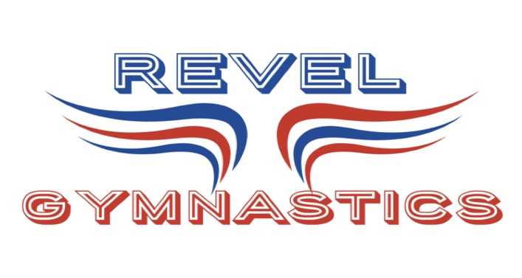
REVEL GYMNASTICS
2021-22 CALENDAR
RECREATIONAL & TRAINING

9/7 – 1ST DAY OF THE FALL SESSION FOR RECREATIONAL & TRAINING GYMNASTS

10/28 – LAST DAY OF FALL SESSION FOR ALL PROGRAMS

11/15 – WINTER RECREATIONAL & TRAINING PROGRAM STARTS

11/23 – 11/27 – GYM CLOSED THANKSGIVING BREAK

12/20-12/31 – GYM CLOSED WINTER BREAK FOR RECREATIONAL & TRAINING PROGRAMS

1/3/22 – WINTER SESSION RESUMES FOR ALL PROGRAMS

1/17 – GYM CLOSED MLK DAY

1/27/22- LAST DAY OF WINTER SESSION FOR RECREATIONAL & TRAINING PROGRAM

REC & TRAINING PROGRAMS TAKE MONTH OF FEBRUARY OFF!!

2/28 – 1ST DAY OF SPRING SESSION FOR ALL PROGRAMS

4/11-4/16 – GYM CLOSED SPRING BREAK FOR ALL PROGRAMS

5/20- LAST DAY OF SPRING SESSION FOR RECREATIONAL & TRAINING PROGRAMS

6/20- FIRST DAY OF SUMMER SESSIONSFOR ALL PROGRAMS

