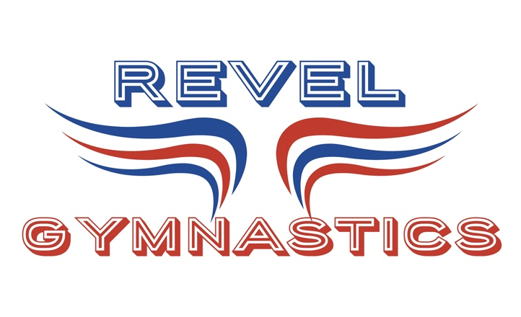
Page 1
July 29, 2023
REVEL GYMNASTICS 2023-24 TRAINING TEAMS INFORMATION
The training team program was created to provide gymnasts with accelerated abilities a place within the program where they could continue to prosper with other gymnasts of similar age, ability and interest.
Being a part of the training program is an opportunity, a chance to see where your gymnast’s interests may lead her. The program goal is your gymnast’s will be able to follow the path in the program that is best fit for her.
Being a part of the training program does not mean your gymnast is now on a timetable of learning. Nor does it mean she may never pass through another REC class again. The plan in the program format is to allow gymnasts to move in and out of levels that best fit her gymnastics needs. A gymnast is happiest when being a positive piece of the practice puzzle. When a gymnast is misplaced. She can become unhappy, disinterested and sometimes even overwhelmed.
This is the primary reason for evaluating gymnasts on a regular basis, and why parent’s inquiries are always welcome. Time to time you will see groups mixing, and coaching changes. This gives other perspective on the gymnast’s mental and physical level.
Gymnasts come in all ages and interests. Many different levels provide an environment that can target specific gymnastics needs. The training and recreational program work side by side to provide proper grouping for girl’s age 4 to 12 years old.
JOT- is design to give the youngest of our gymnasts a place to learn more challenging gymnastics activities. Listening and motor skills are top priority. There are 2 levels within the JOT program. Age is relevant to grouping. Path is Advanced JOT. JOT’s meets once per week for 60 minutes. JOT’s are encouraged to attend a minimum of 1 weeks of summer camp to show program commitment.
ADV JOT (AJ) -is designed to bring together gymnasts with select physical qualities and good gym focus. REVEL wants to avoid the “I’m bored” syndrome. Ideas of grouping gymnasts with accelerated skill potential allows for more challenging and fun development. This training team is the next step after JOT. ADV JOT continues on with the same fun but let’s get it done mentality! Gymnasts in this group attend 1-75 minute class per week. ADV JOT works on all Olympic events. Placement into the ADV JOT is by advancement from JOT or by recommendation. Ages 5-7. Class ratio is 5 to 1. ADV JOT are encouraged to attend a minimum of 1 weeks of summer camp to show program commitment.
DOT- is the top of our elementary age training team program. Strong basic elements provide foundation for developing entry level competitive gymnastics skills on all of the Olympic events. This team is the last step before competitive Silver training team. Gymnasts on this team are working towards skills requirements to fulfill NGA Silver competitive routines. DOT is a year-round training team. DOT meets 2 days a week for 90 minutes during the school year. Ages 5-9. Class ratio is 8:1. DOTs are encouraged to attend 1 week of summer camp to show program commitment. DOT’s aspiring to advance to Silver trainer are required to attend 3 weeks of summer Silver Trainers camp.

