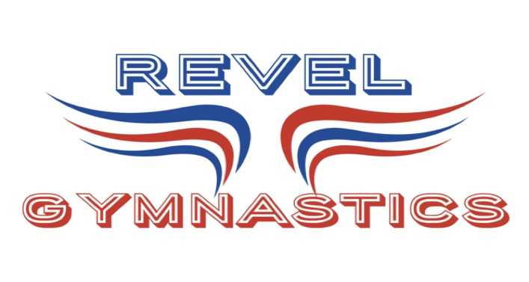
REVEL GYMNASTICS
2022-23 CALENDAR
RECREATIONAL & TRAINING

9/6/22 – 1ST DAY OF THE FALL SESSION FOR RECREATIONAL & TRAINING GYMNASTS

10/24/22-10/27/22- SHOW WEEK FOR RECREATIONAL & TRAINING GYMNASTS

10/27/22 – LAST DAY OF FALL SESSION FOR ALL PROGRAMS

11/2/22 – WINTER RECREATIONAL & TRAINING PROGRAM STARTS

11/23/22 – 11/27/22 – GYM CLOSED THANKSGIVING BREAK

12/20/22-1/2/23 – GYM CLOSED WINTER BREAK FOR RECREATIONAL & TRAINING PROGRAMS

1/3/23 – WINTER SESSION RESUMES FOR ALL PROGRAMS

1/16/23-1/19/23- SHOW WEEK FOR RECREATIONAL & TRAINING GYMNASTS

1/19/23- LAST DAY OF WINTER SESSION FOR RECREATIONAL & TRAINING PROGRAM

REC & TRAINING PROGRAMS TAKE MONTH OF FEBRUARY 2023 OFF!!

3/1/23 – 1ST DAY OF SPRING SESSION FOR ALL PROGRAMS

4/1/23-4/9/23 – GYM CLOSED SPRING BREAK FOR ALL PROGRAMS

5/15/23-5/18/23- SHOW WEEK FOR RECREATIONAL & TRAINING GYMNASTS

5/19/23- LAST DAY OF SPRING SESSION FOR RECREATIONAL & TRAINING PROGRAMS

6/12/23- SUMMER SESSION WEEK #1 FOR ALL PROGRAMS BEGIN

